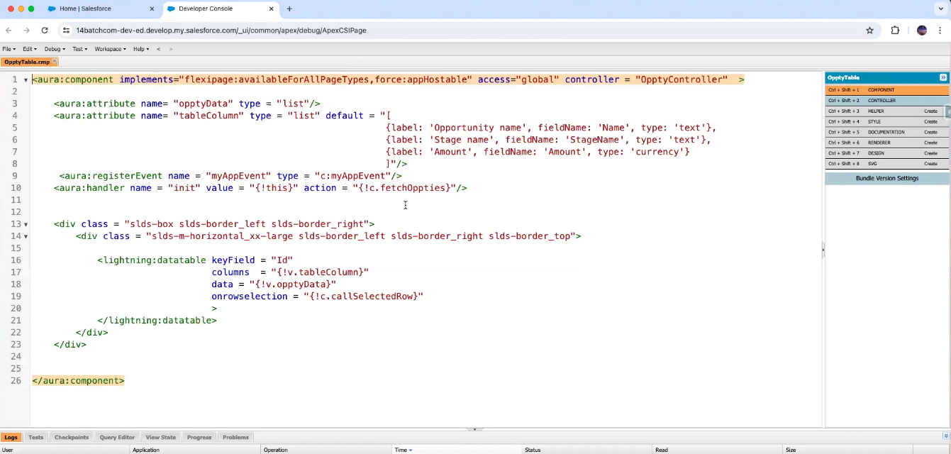

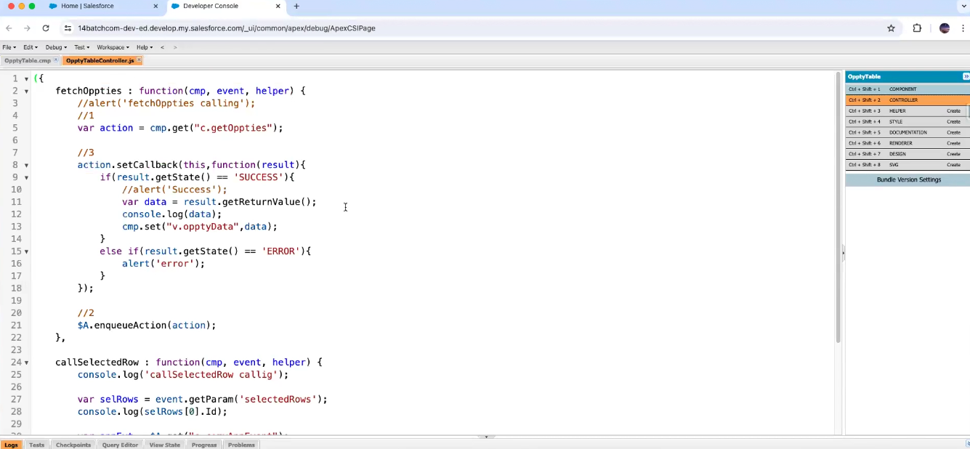

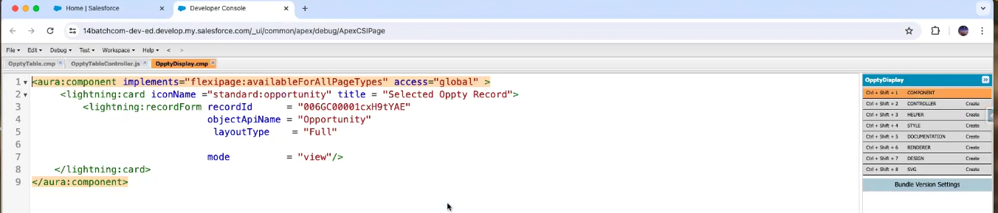

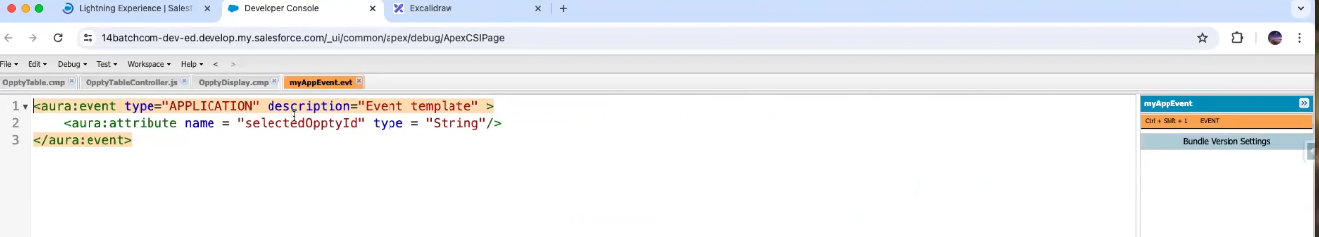

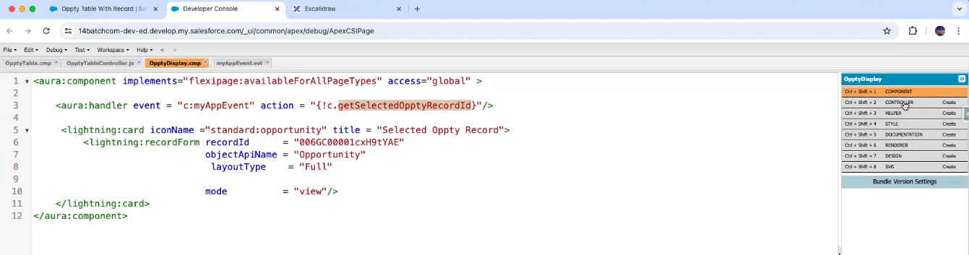

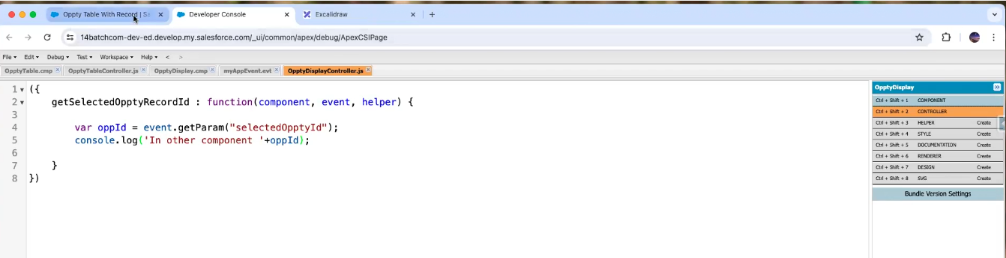

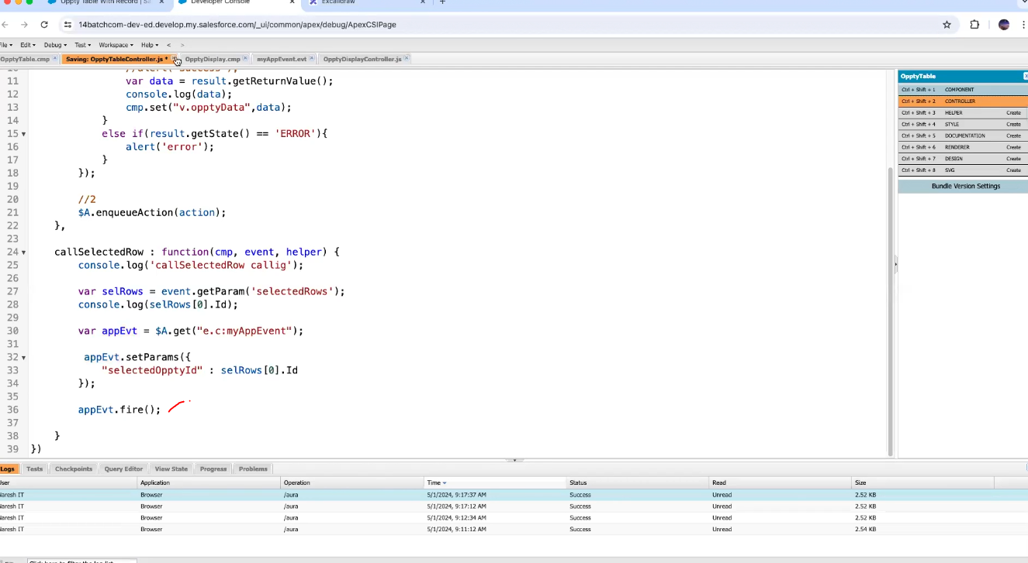

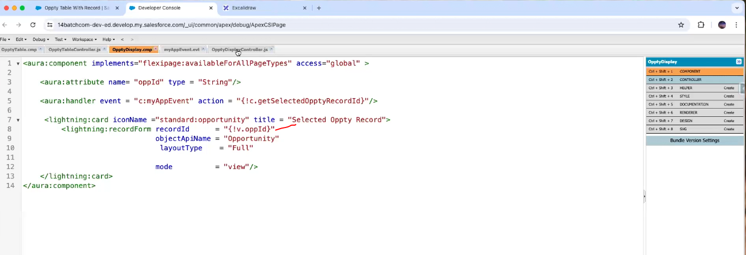

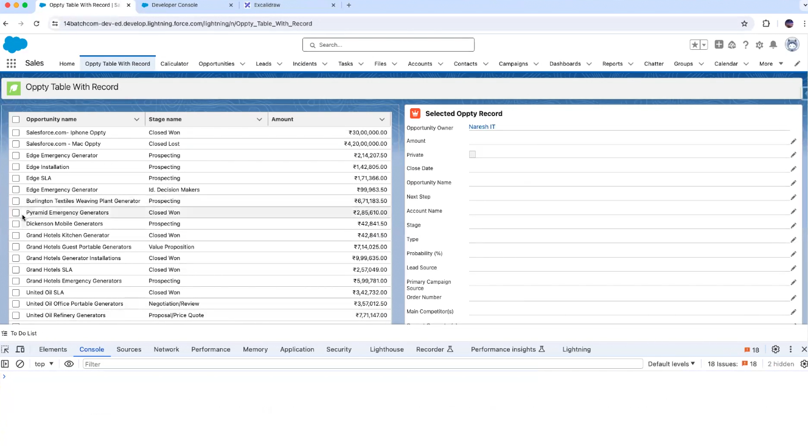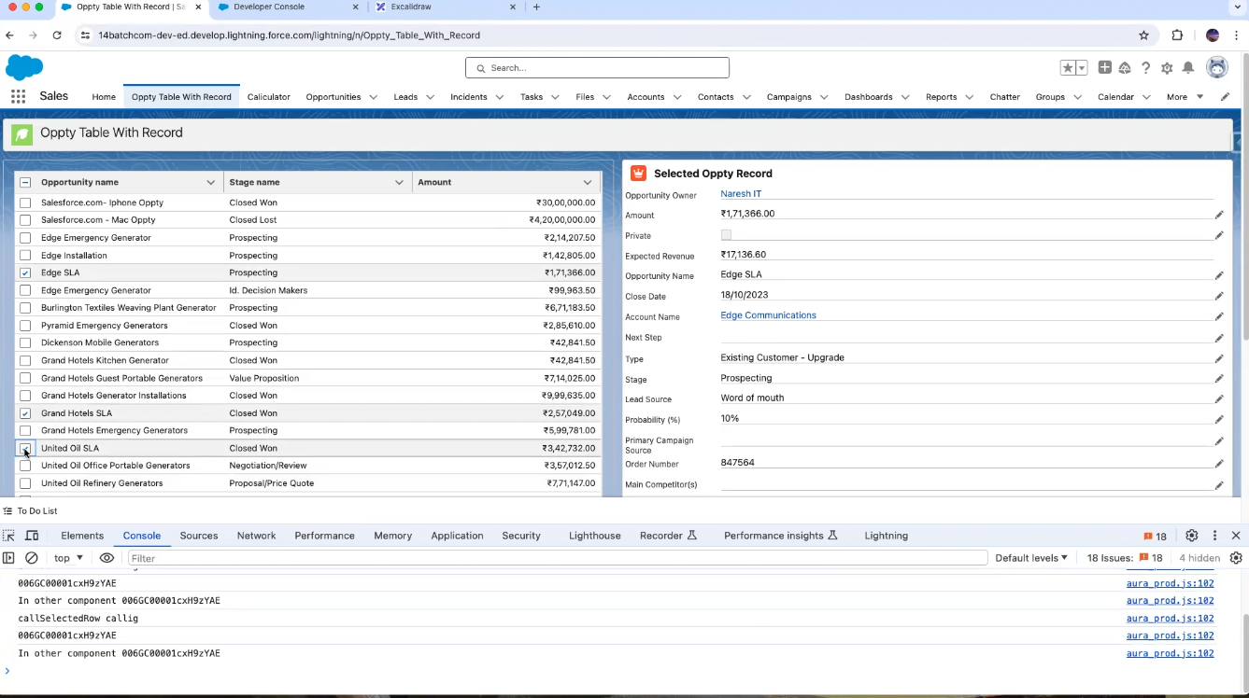

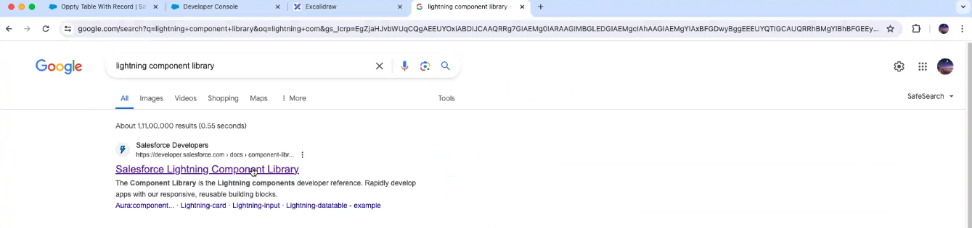

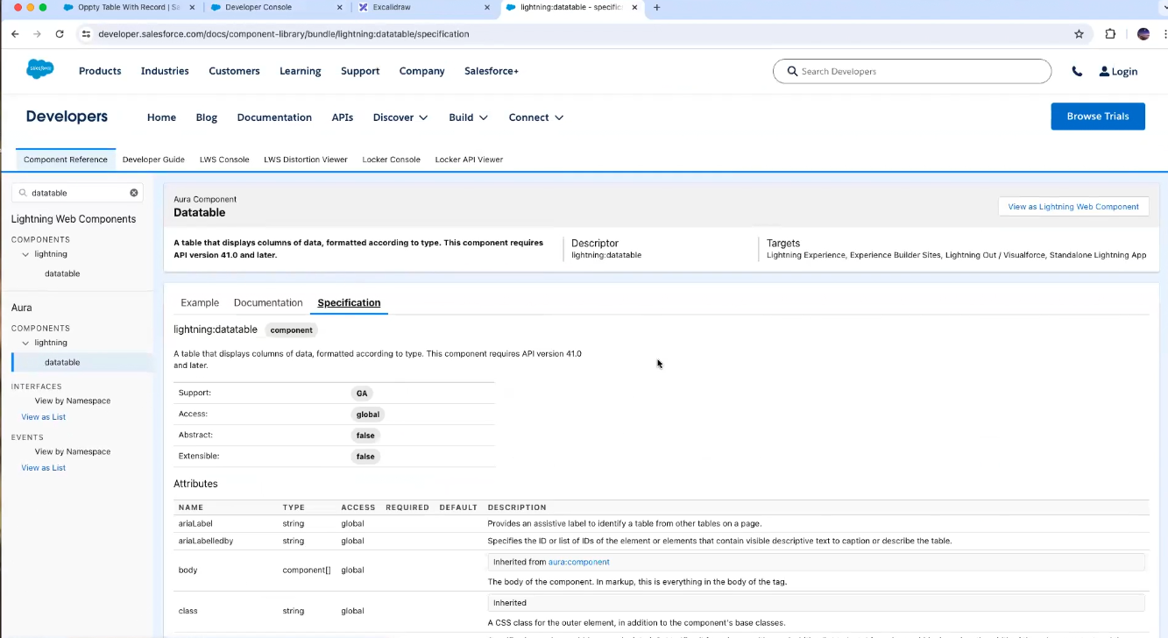

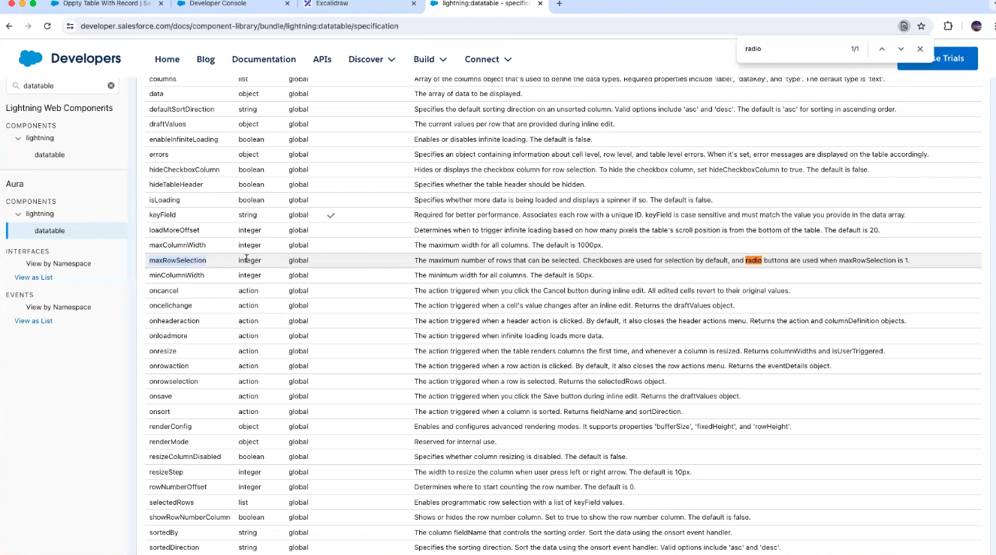

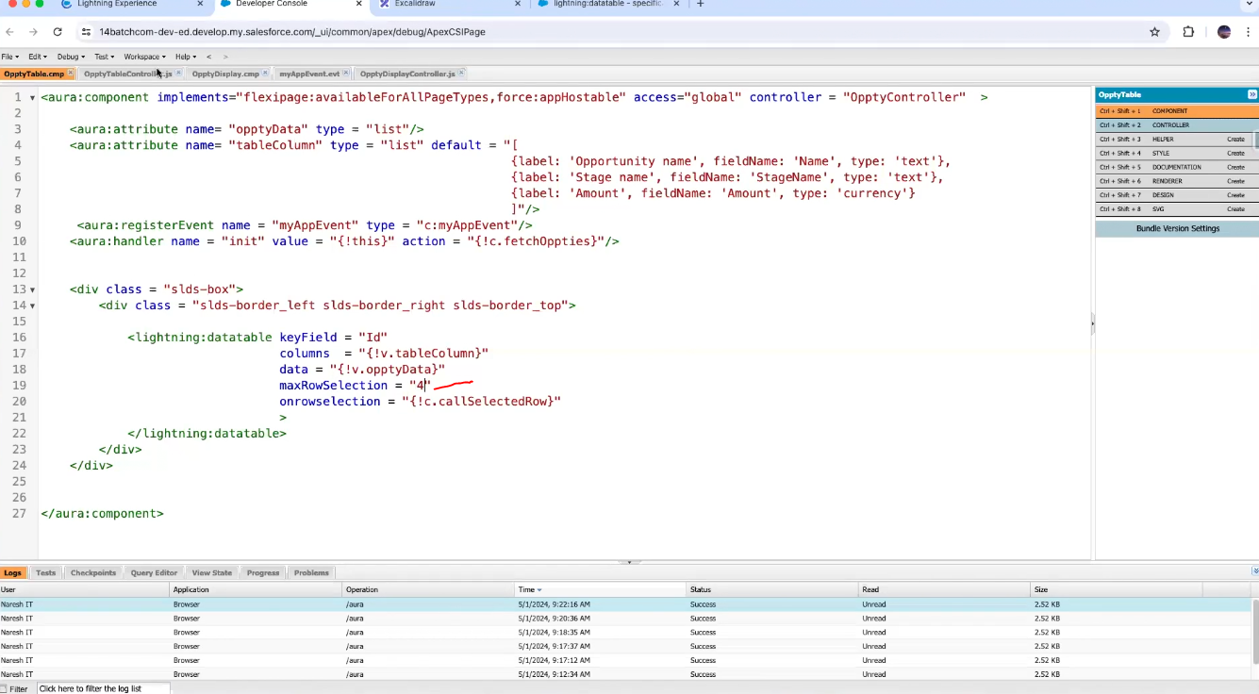

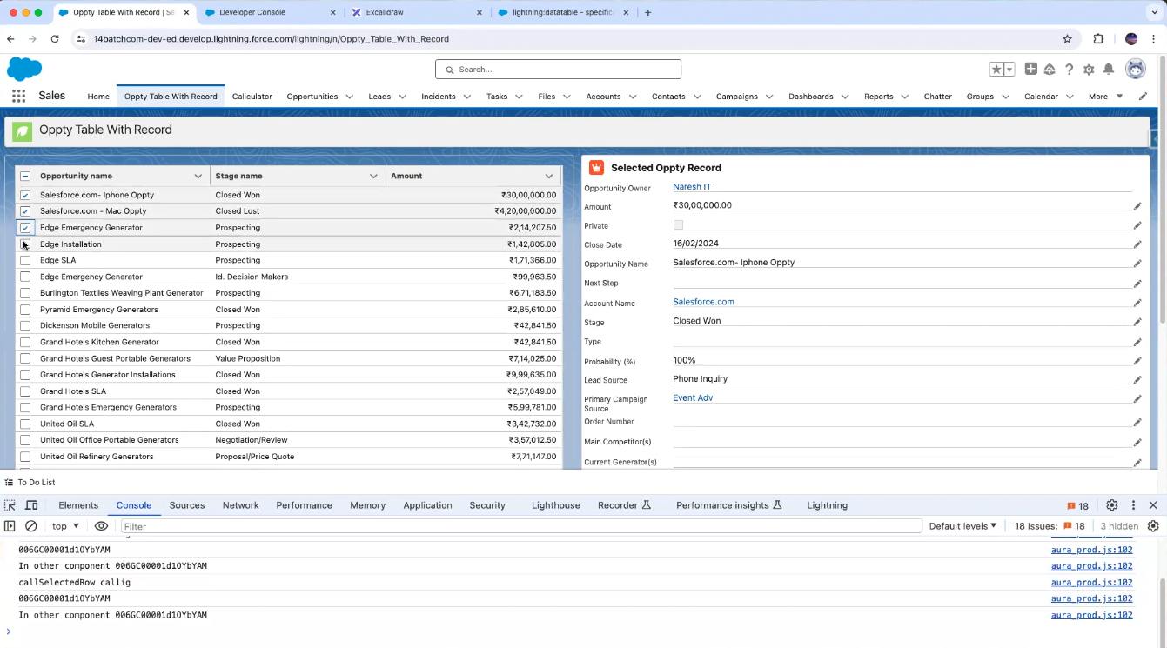

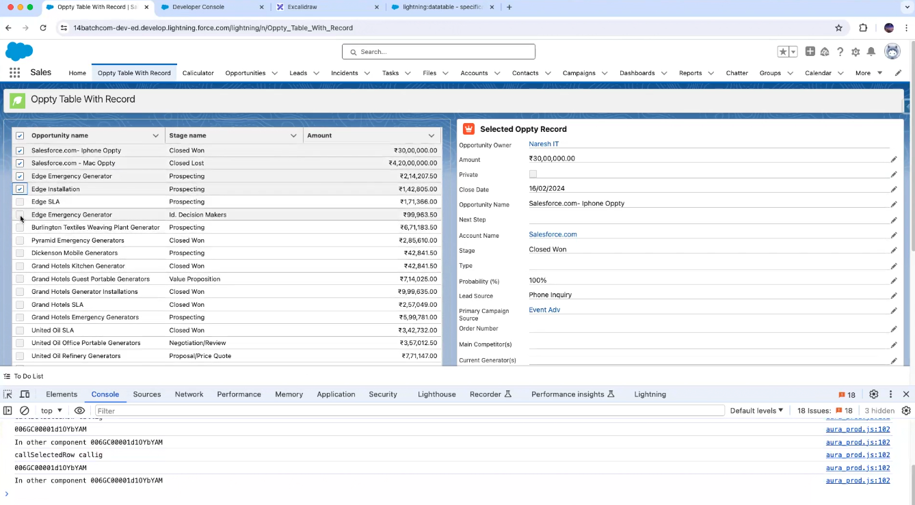

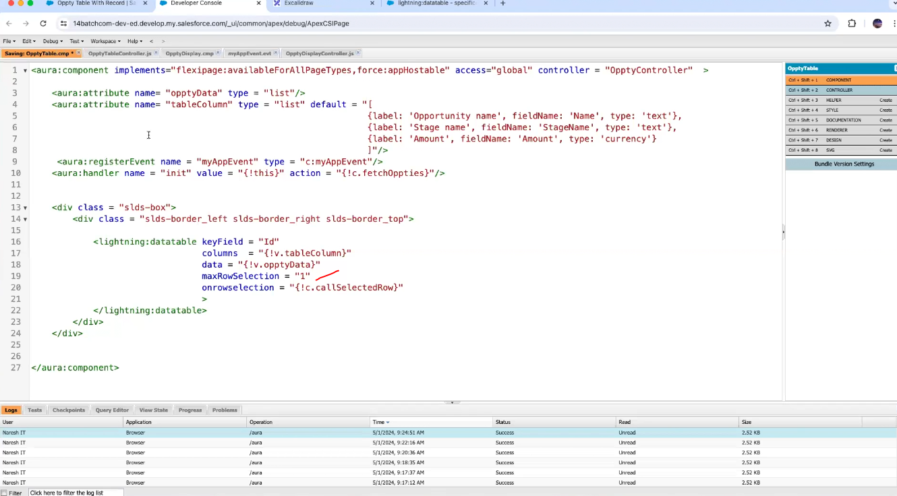

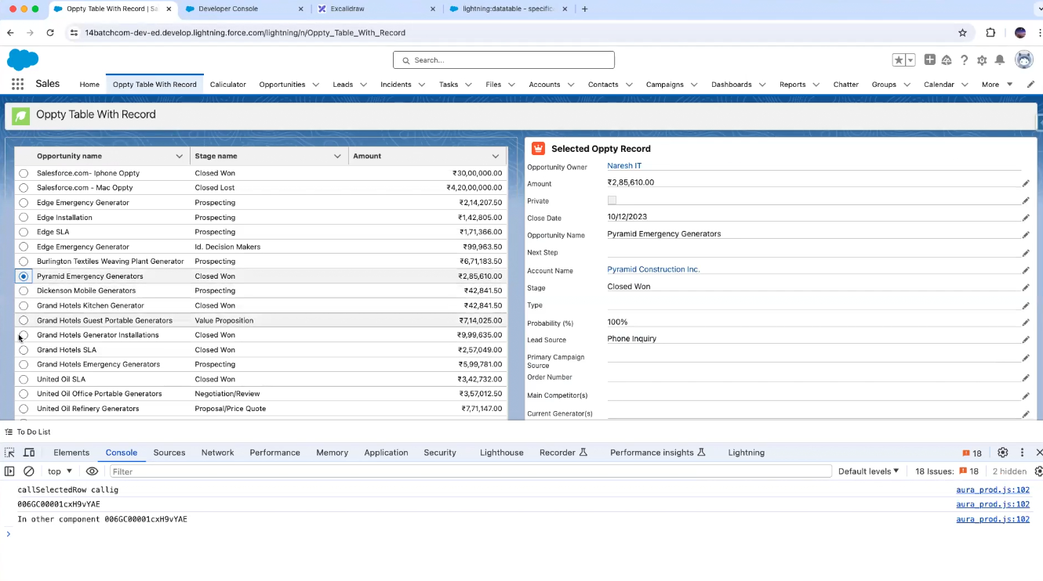

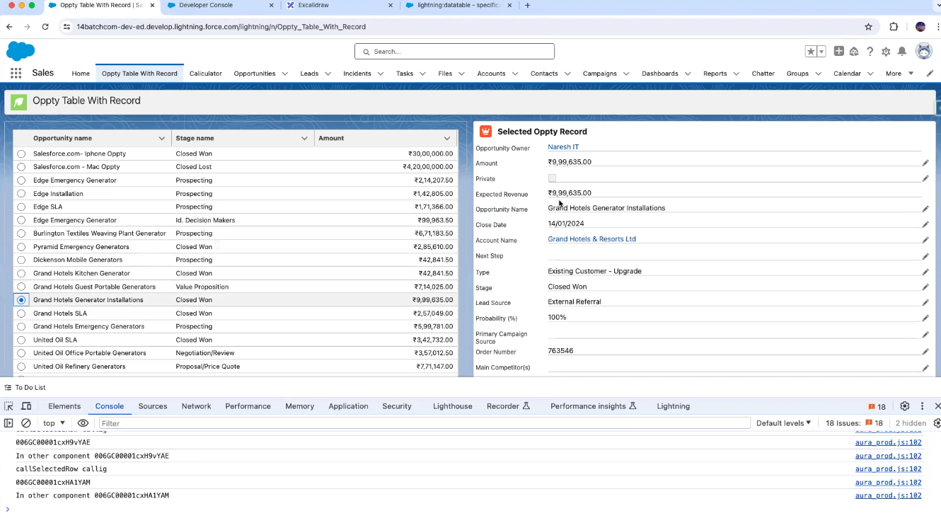

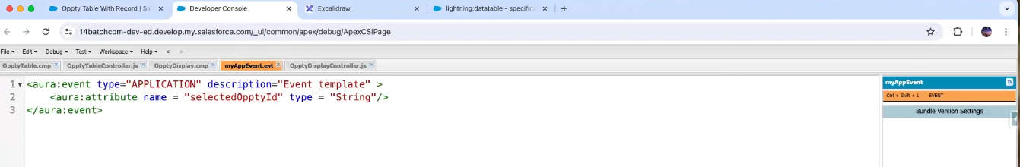

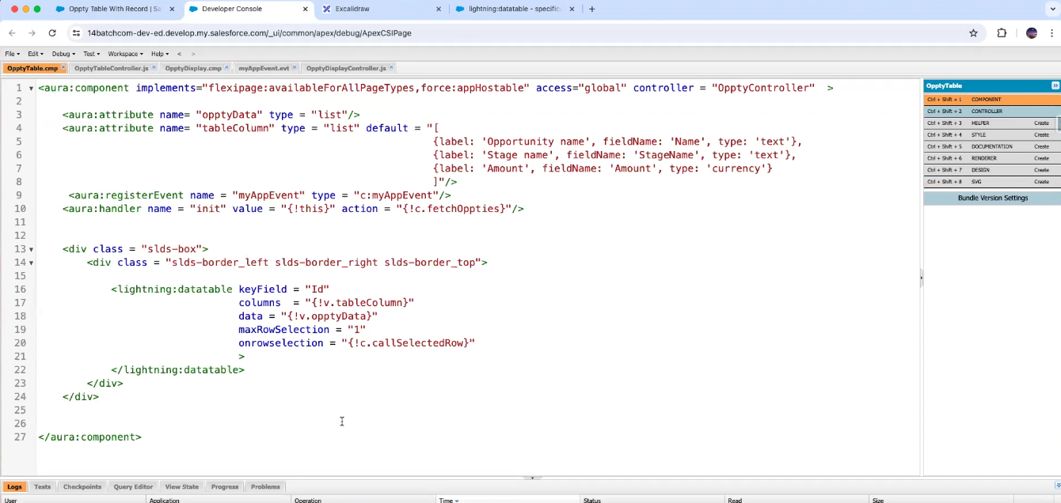

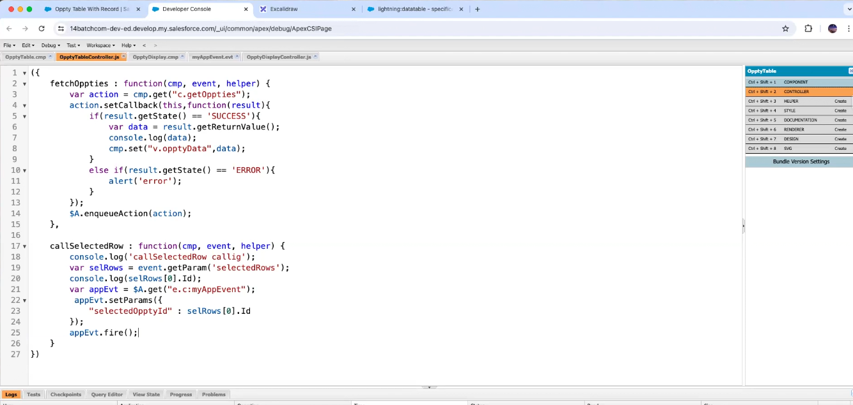

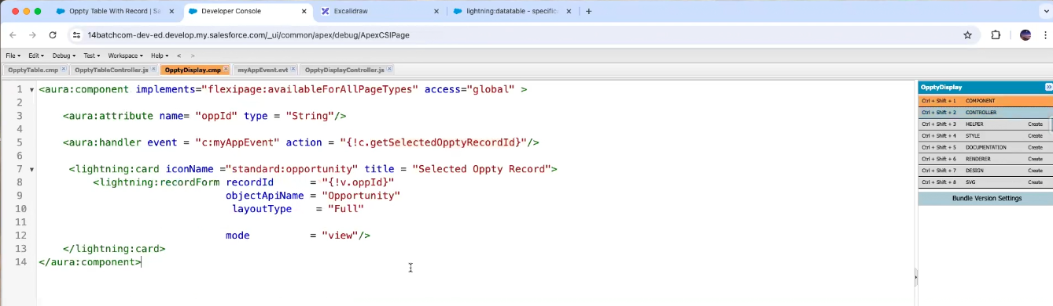

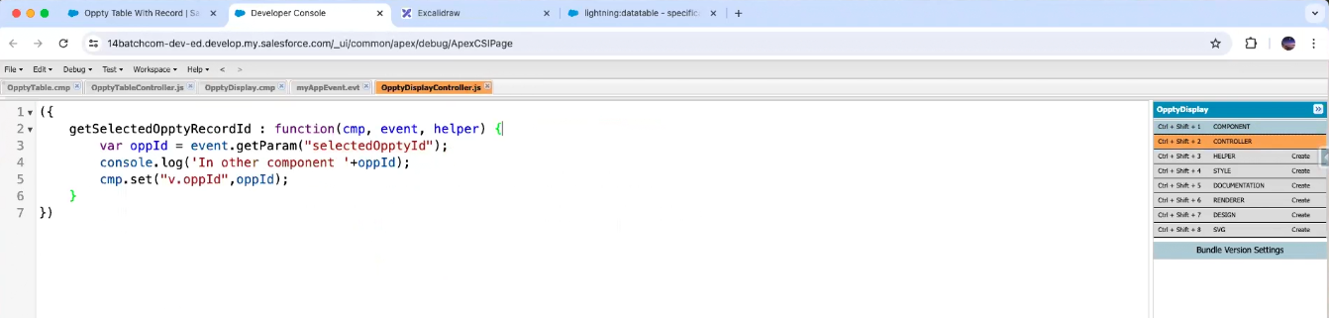

Two individual components we are passing the data

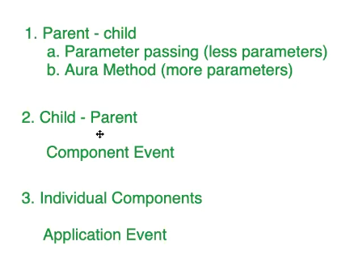

This event-based communication or communication between two components

This is multiple component communication

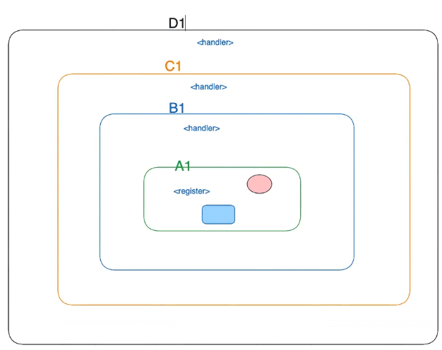

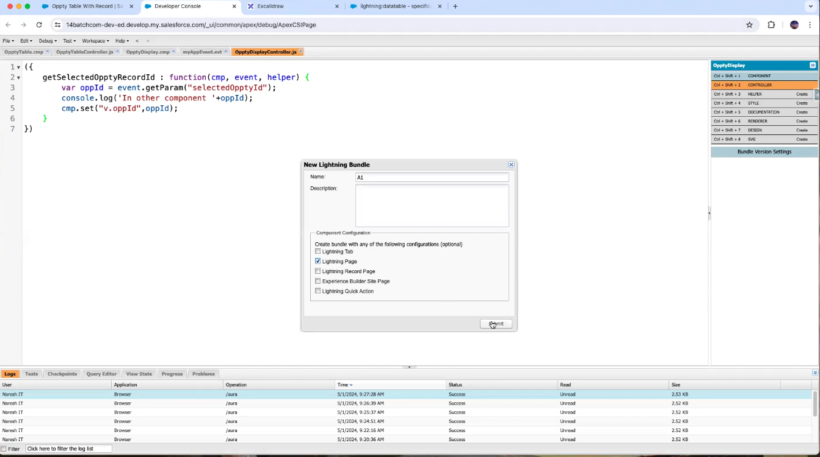

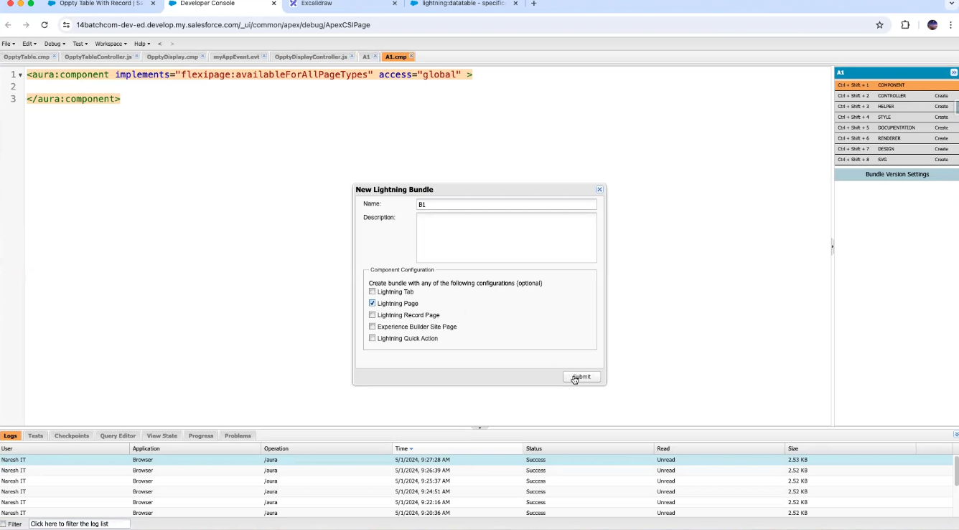

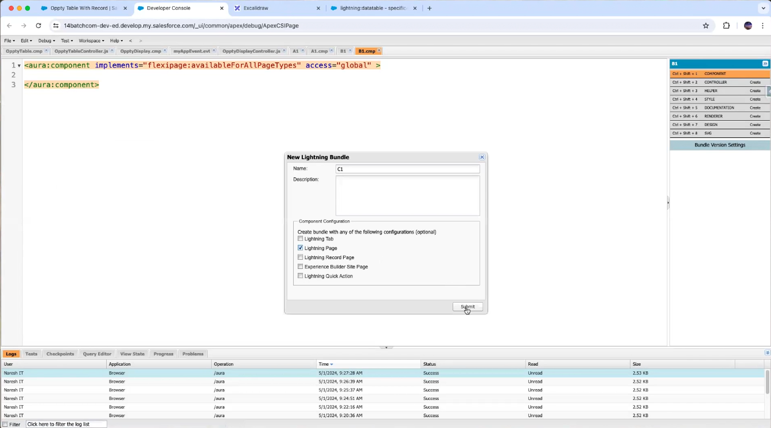

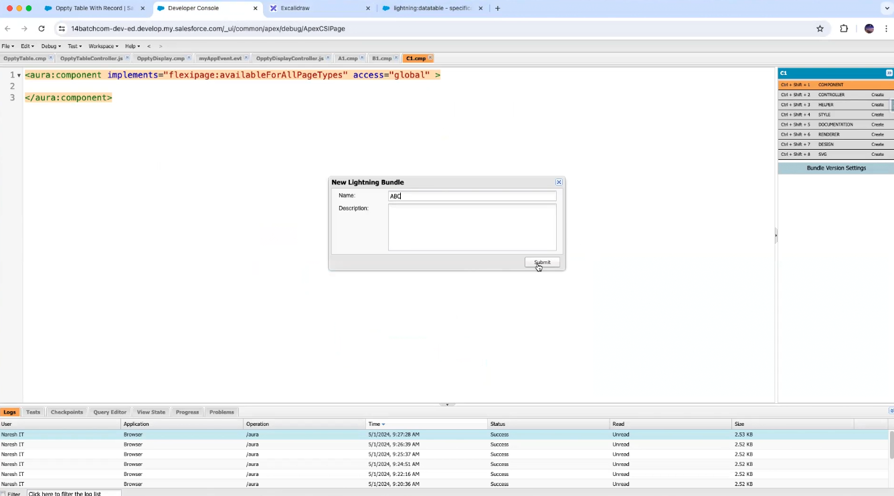

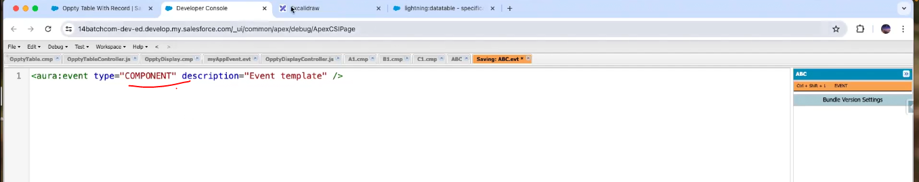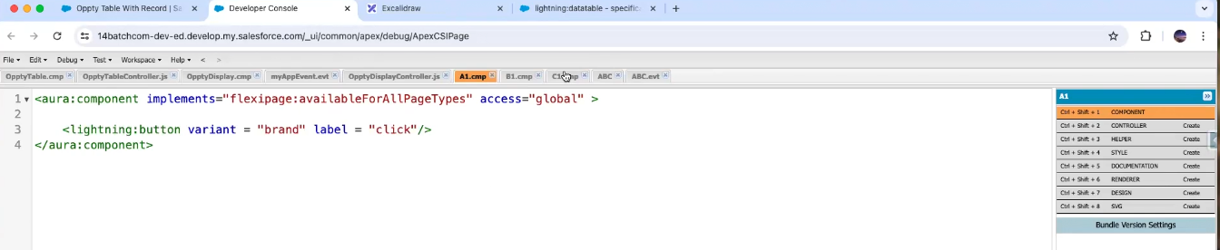

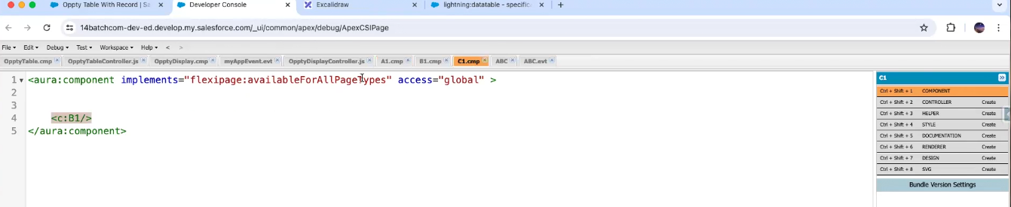

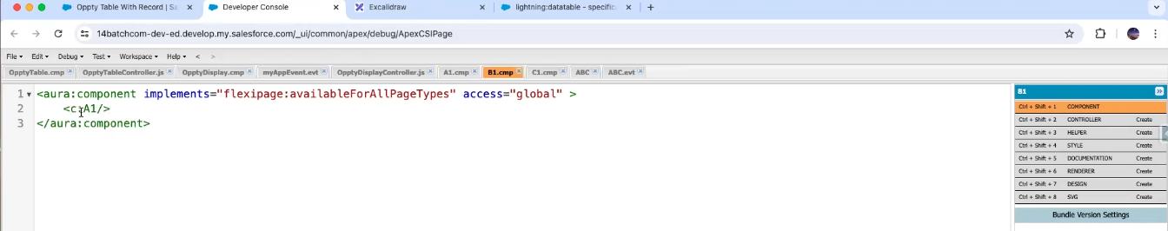

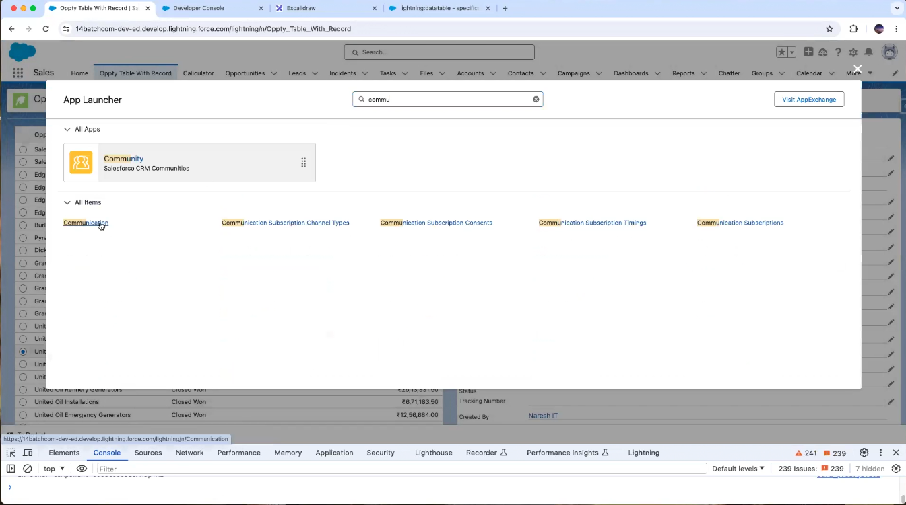

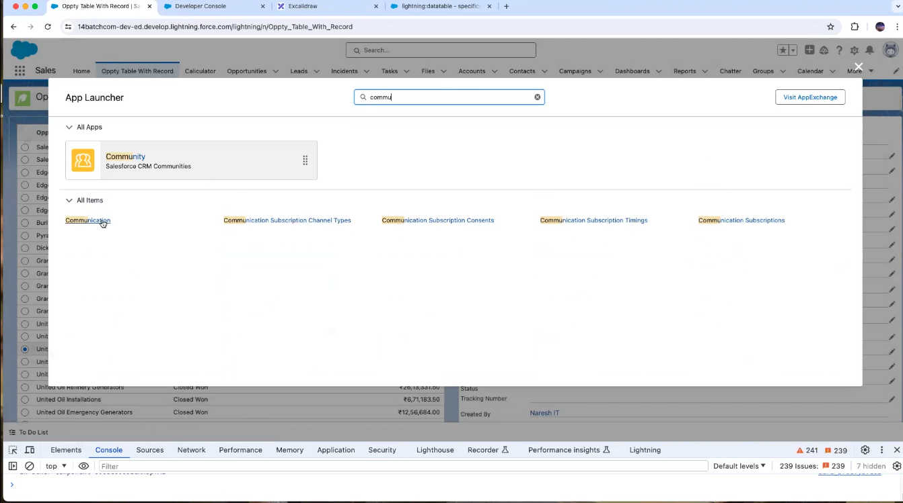

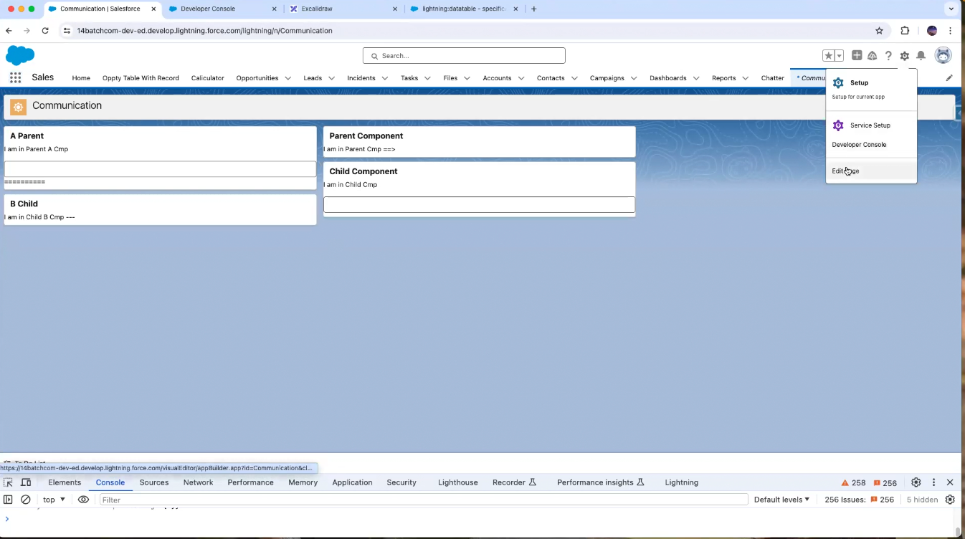

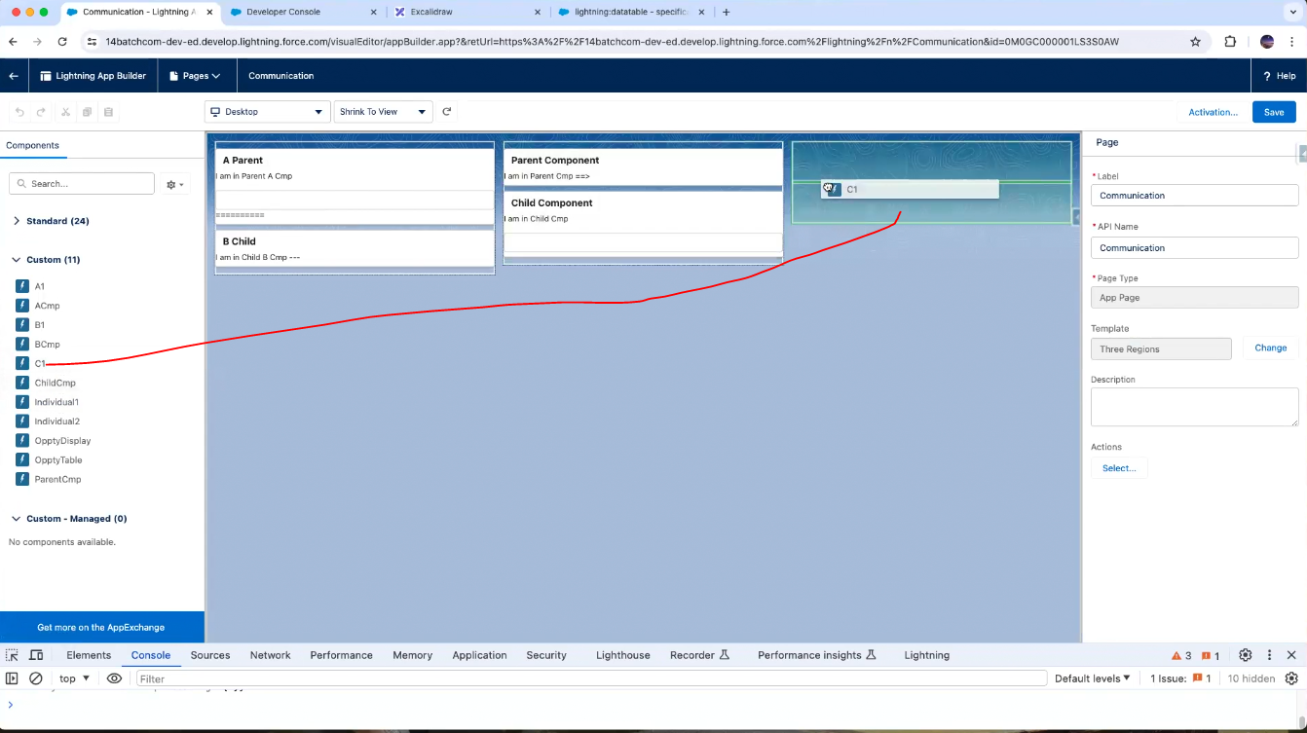

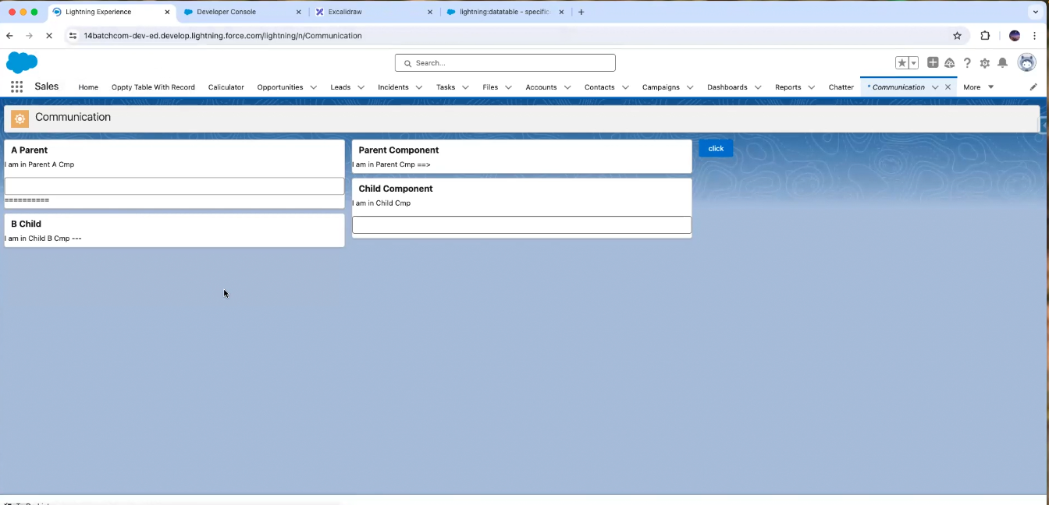

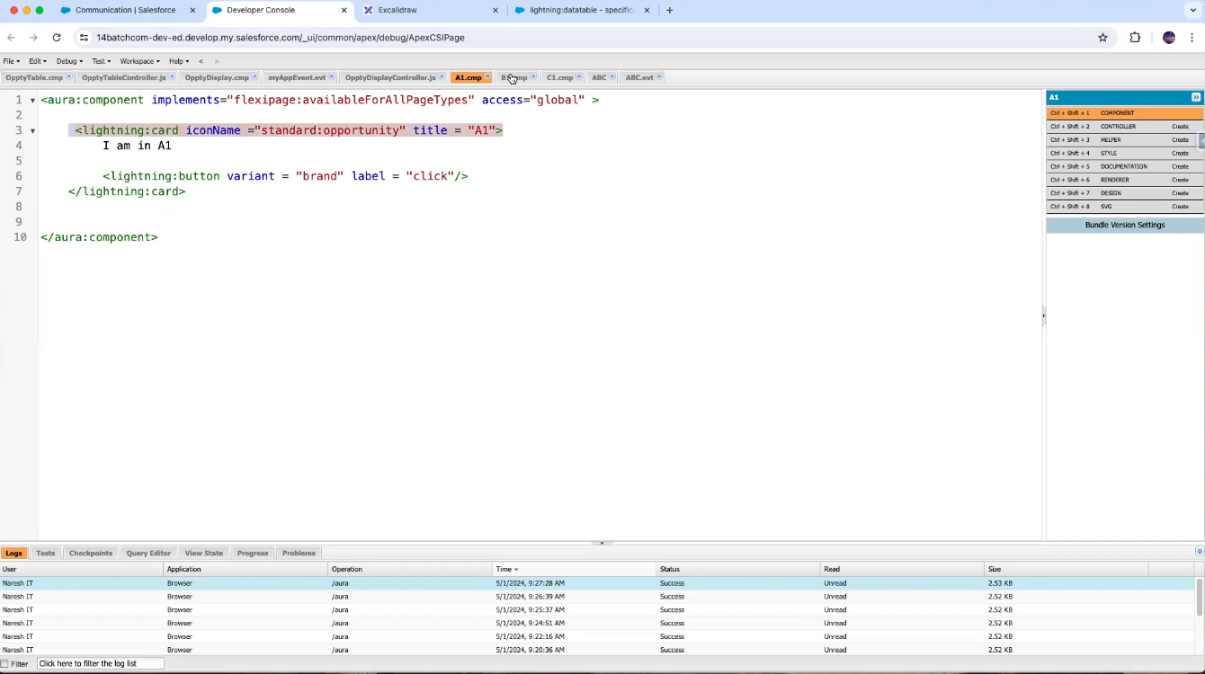

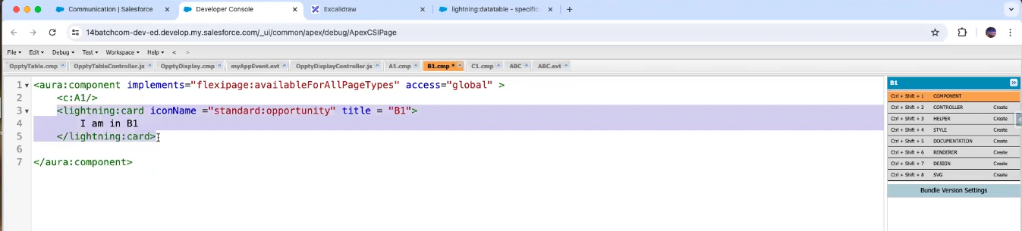

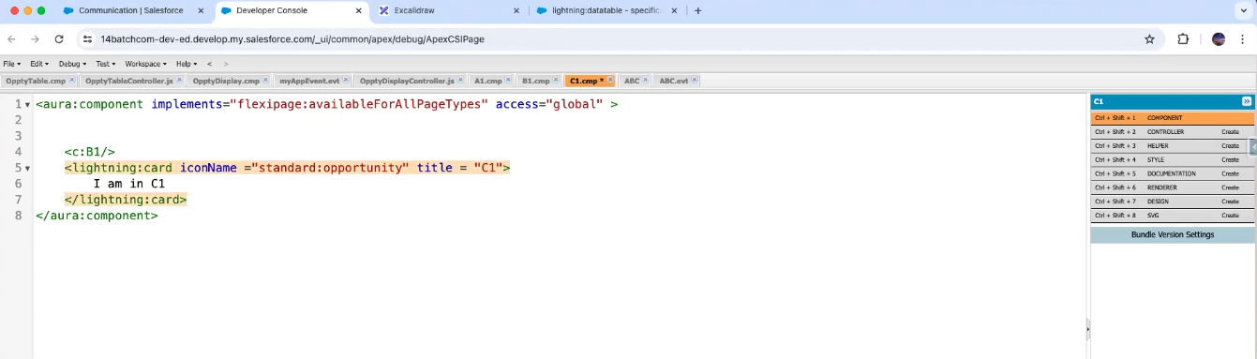

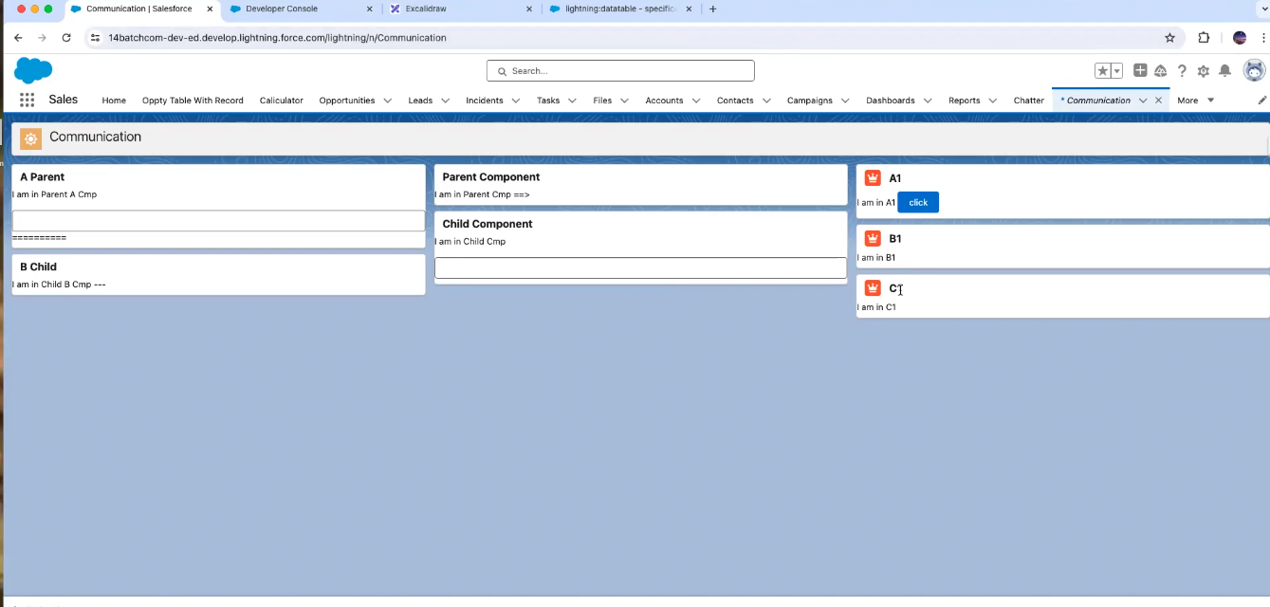

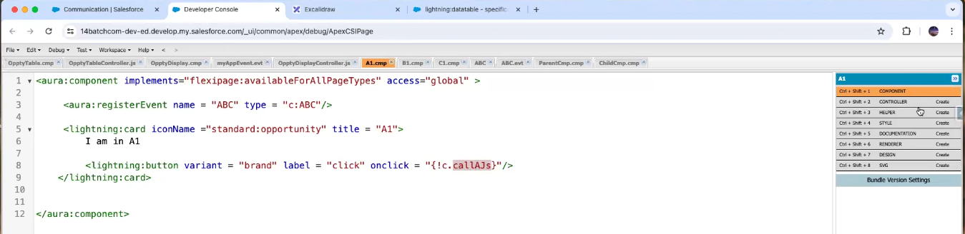

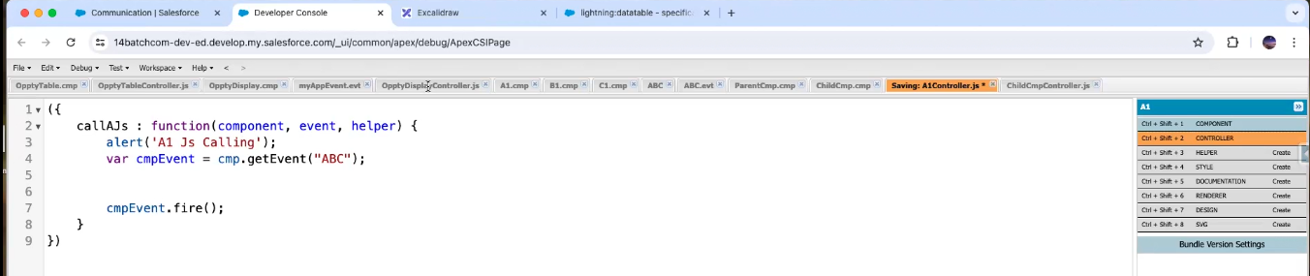

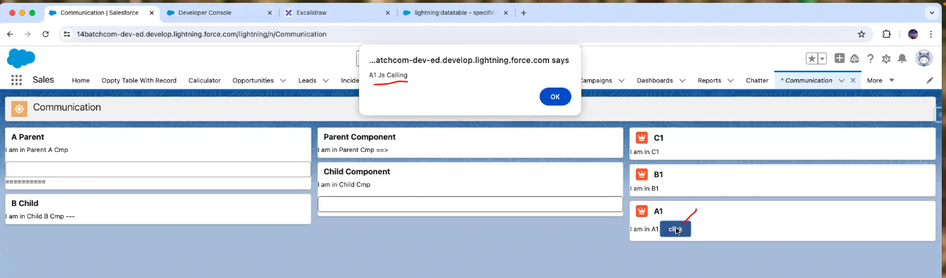

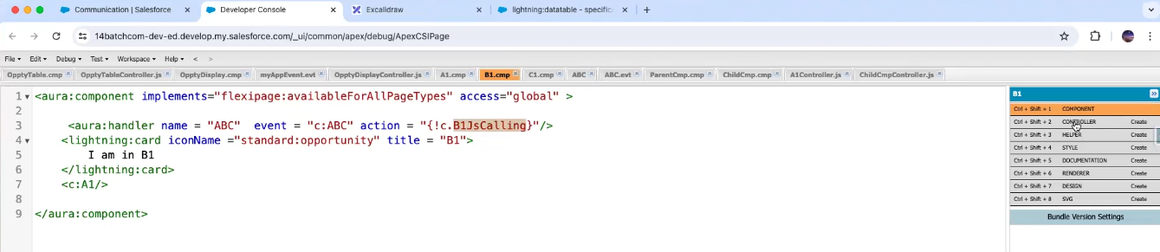

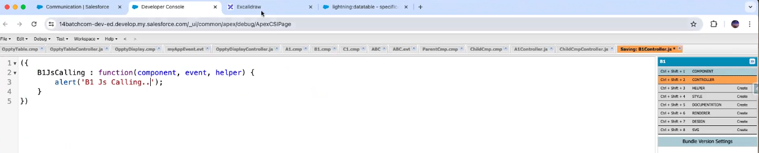

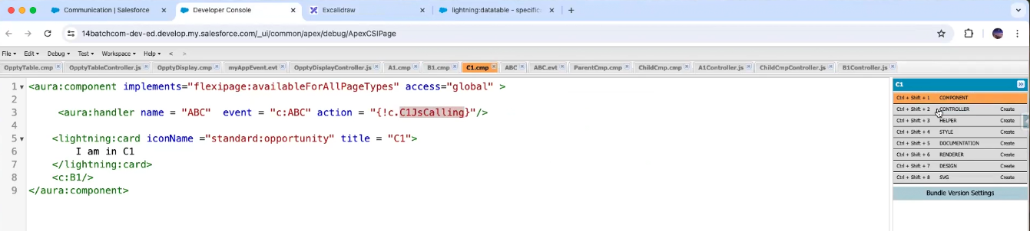

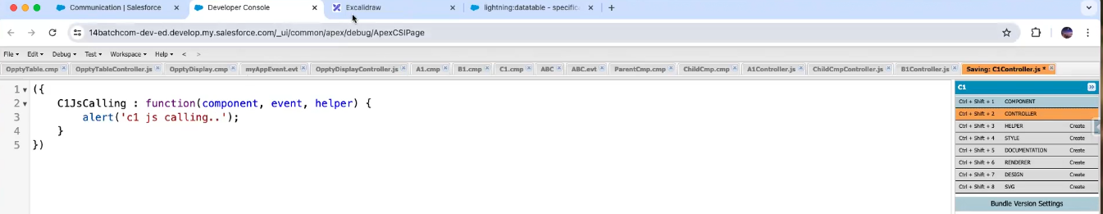

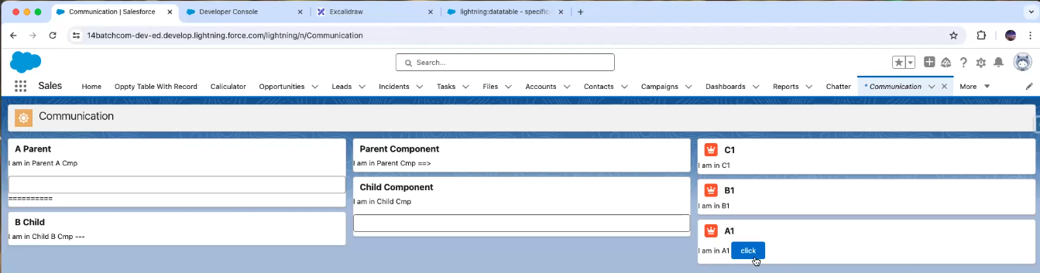

Some problem in code

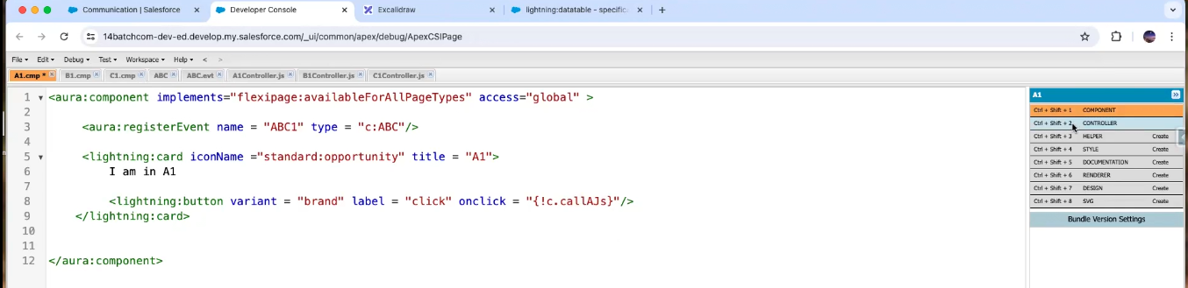

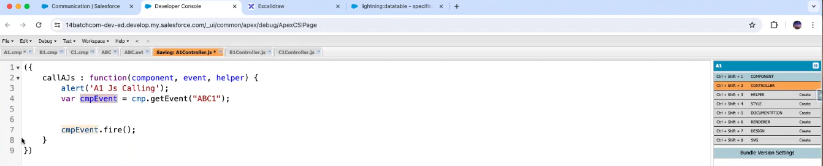

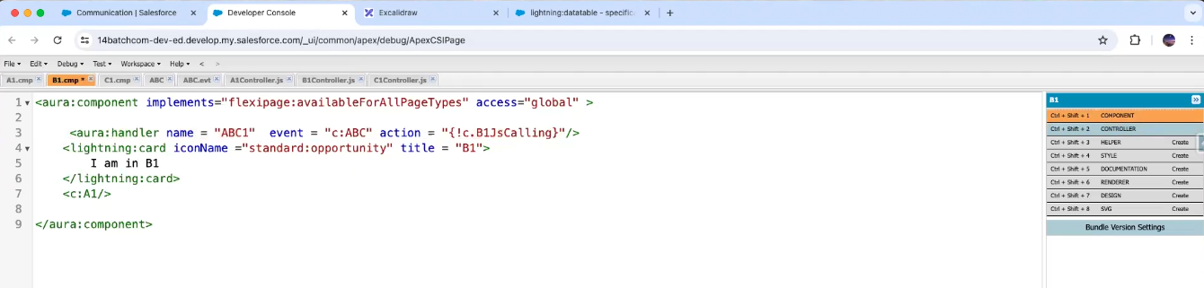

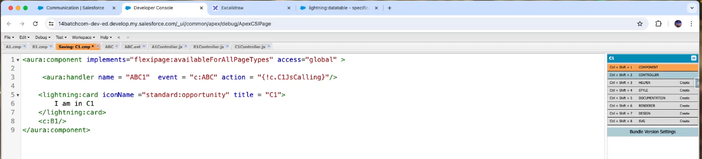

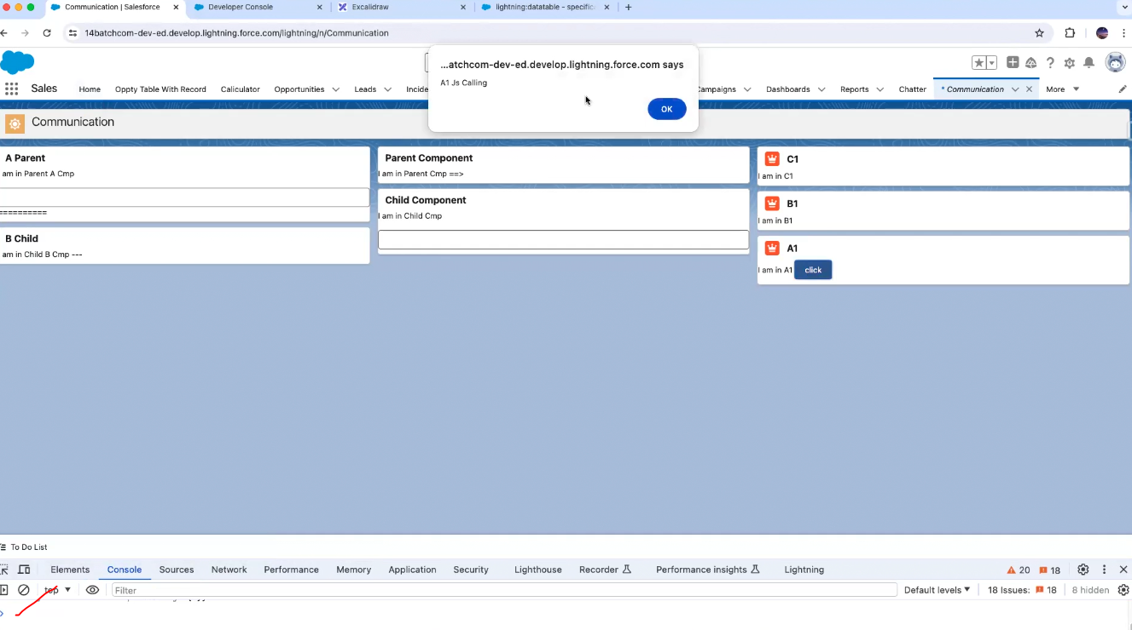

This is also not working

I am creating new event

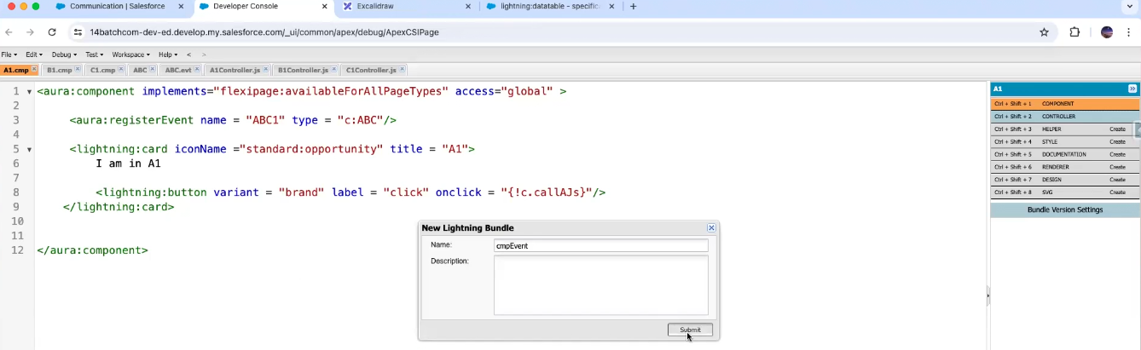

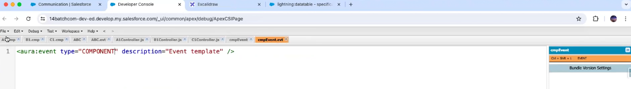

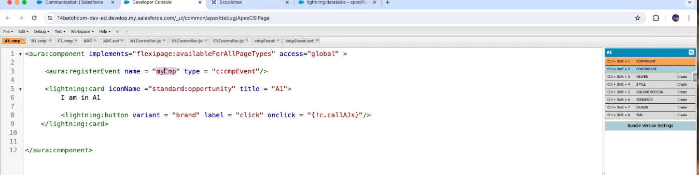

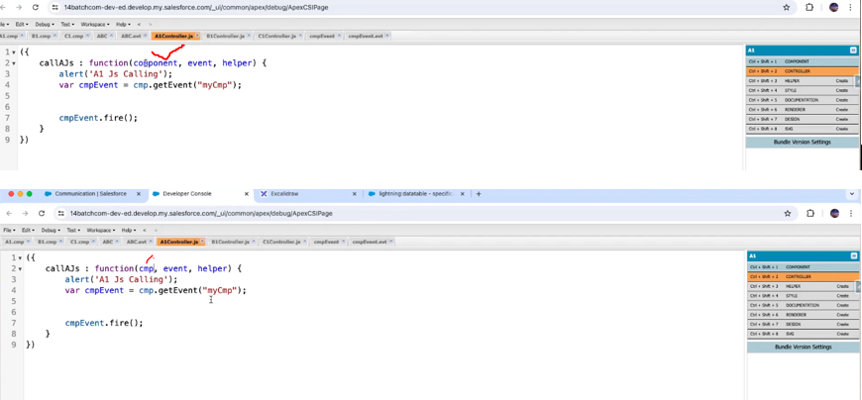

This is the problem in above

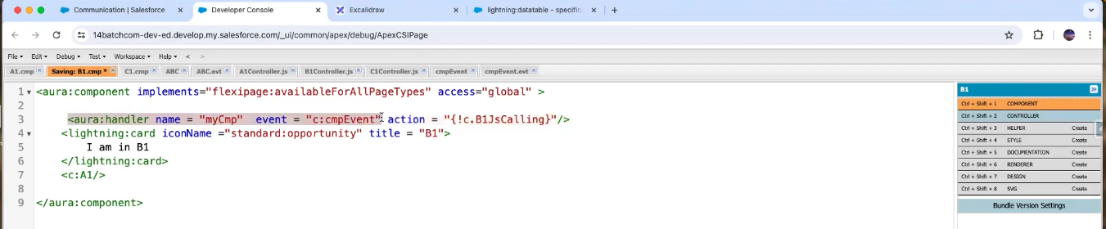

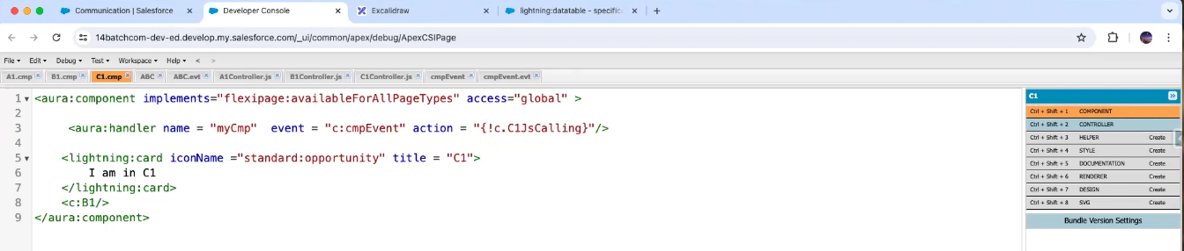

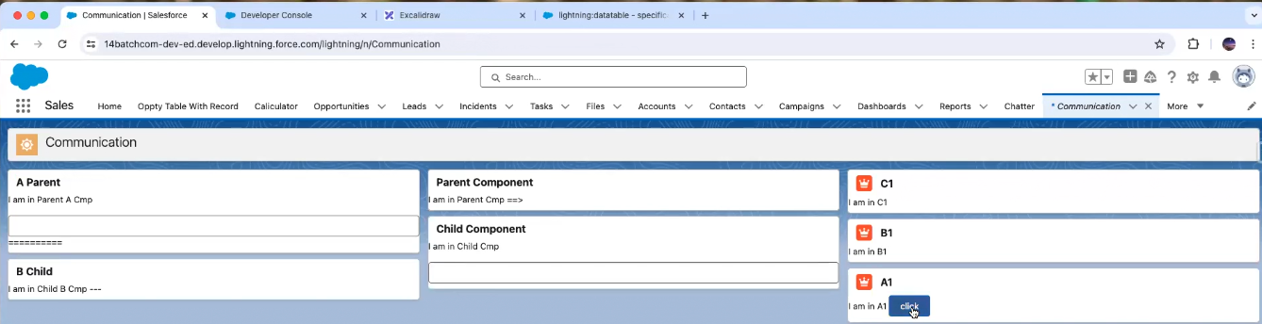

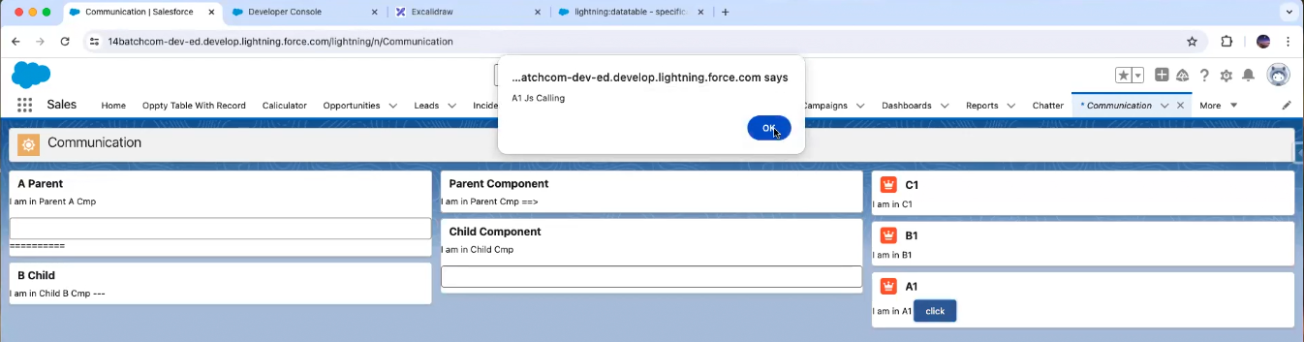

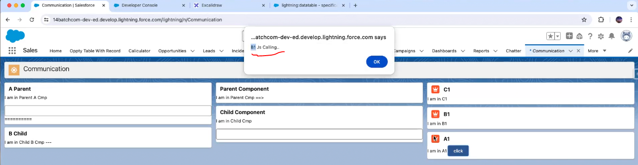

Then click on ok

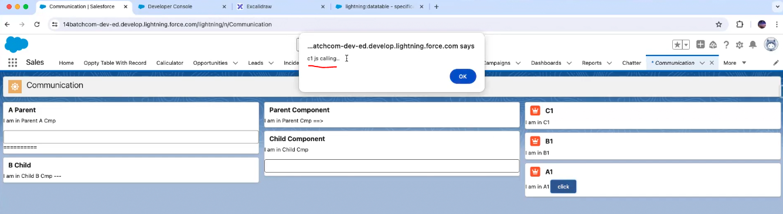

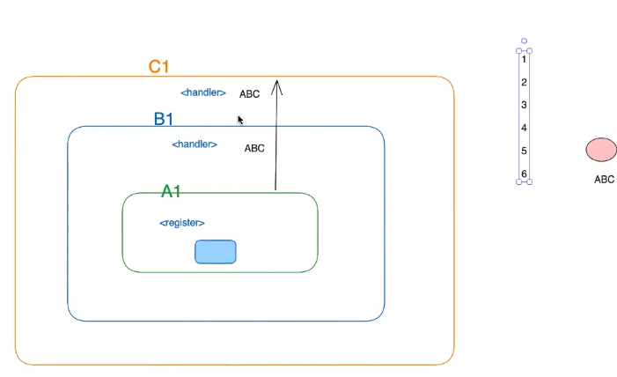

If we have many components as above using one component

If event in child component is fired it is going to call next parent component

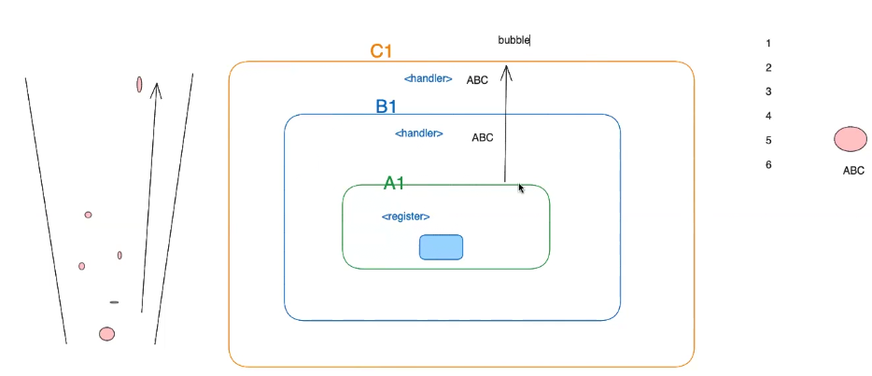

The event traversing from bottom to top is known as bubble traversing

**🔹 Event Propagation in Salesforce UI (Aura / LWC)**

When an event is fired in a component, Salesforce follows a **traversing mechanism** to decide **how the event reaches parent/child components**. This process has two main phases:

1. **Capture Phase** (top → down)
   * The event starts at the top-level container (like the application root) and travels **downward** to the component where the event was fired.
2. **Bubble Phase** (bottom → up)
   * After reaching the source, the event **bubbles upward** through the parent components, one by one, until it reaches the topmost container (like app or dom).

**🔹 Bubble Traversing in Salesforce**

* **Bubble traversing** means **moving the event from child to parent components**.
* Example: If a button click event is fired inside a child component → it **bubbles up** so parent components can also handle it (if they have registered for that event).

Now reverse direction from top to bottom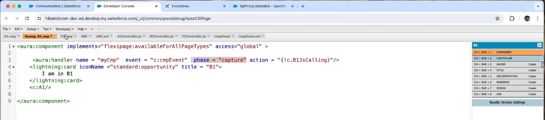

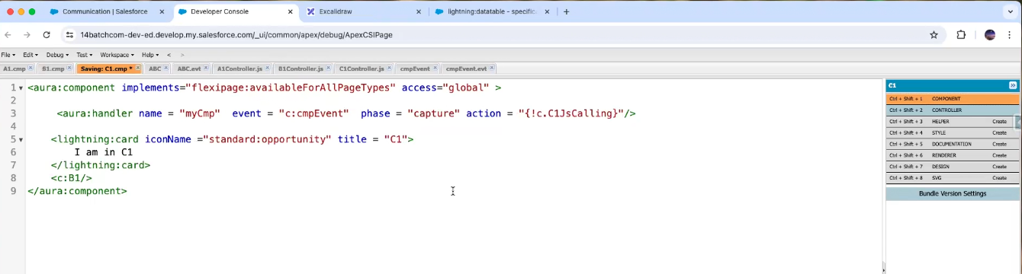

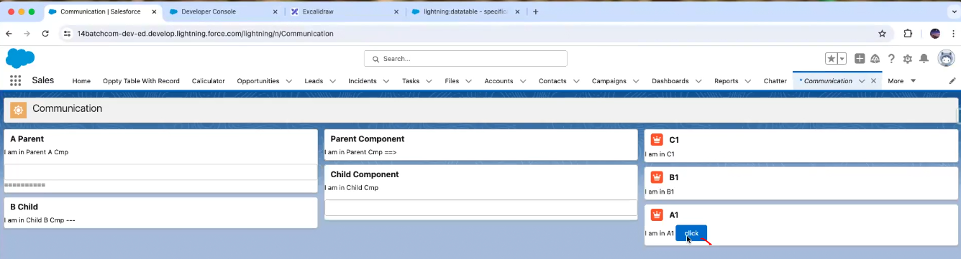

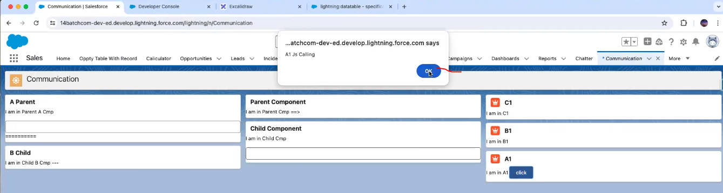

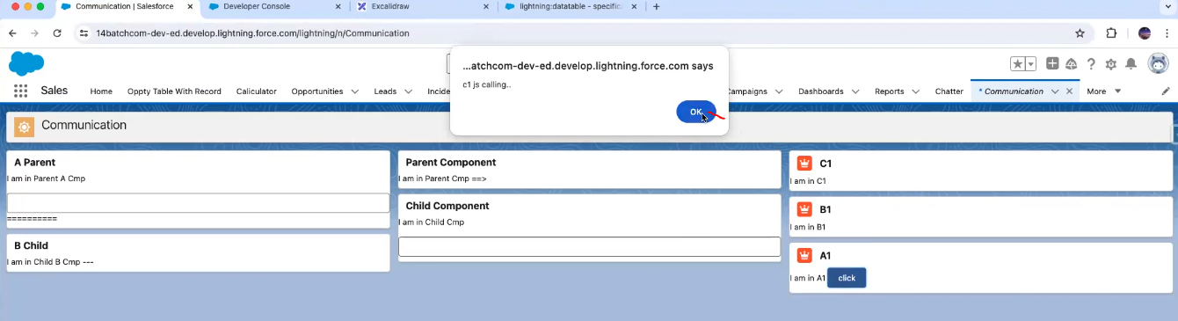

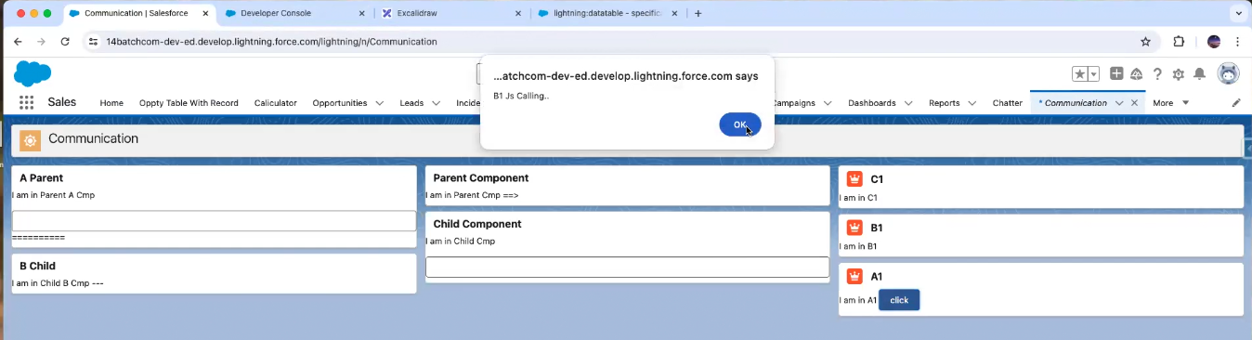

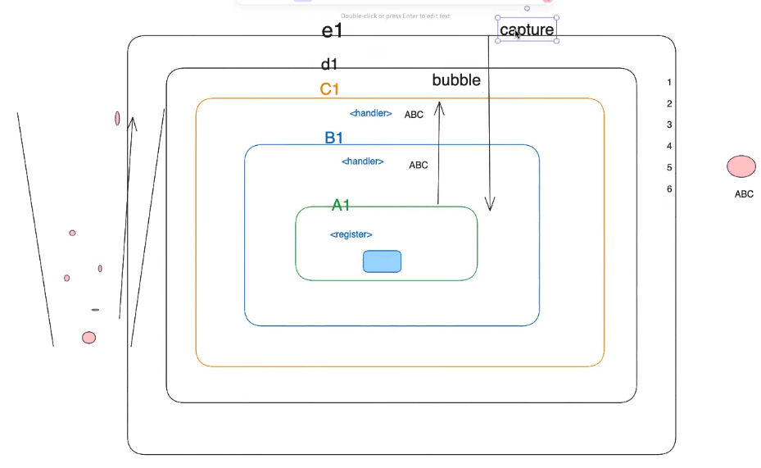

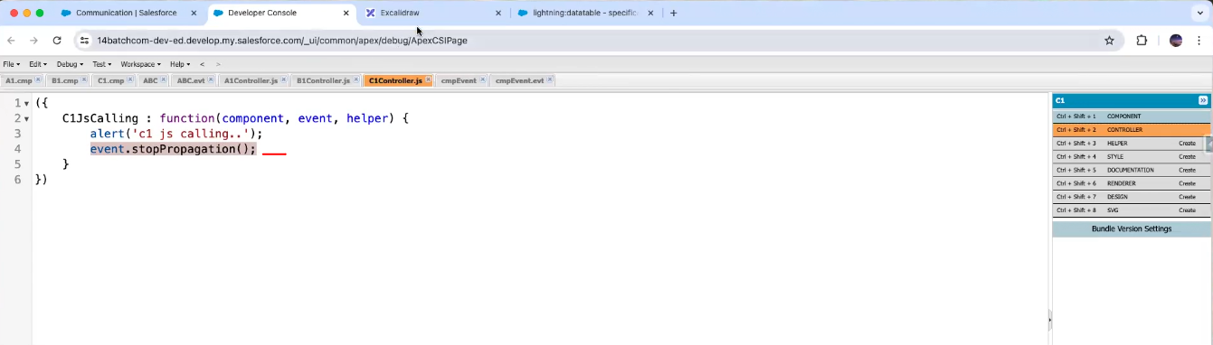

Means after moving to c1 then don’t go to B1

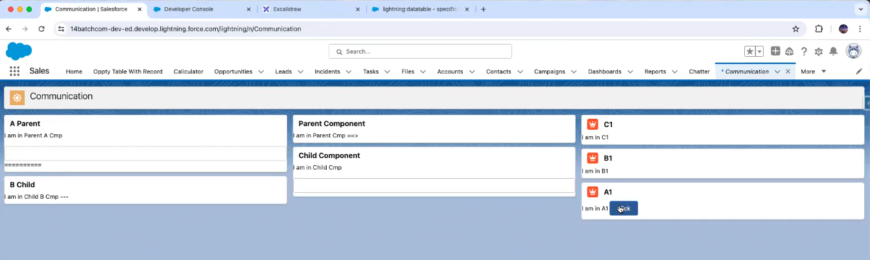

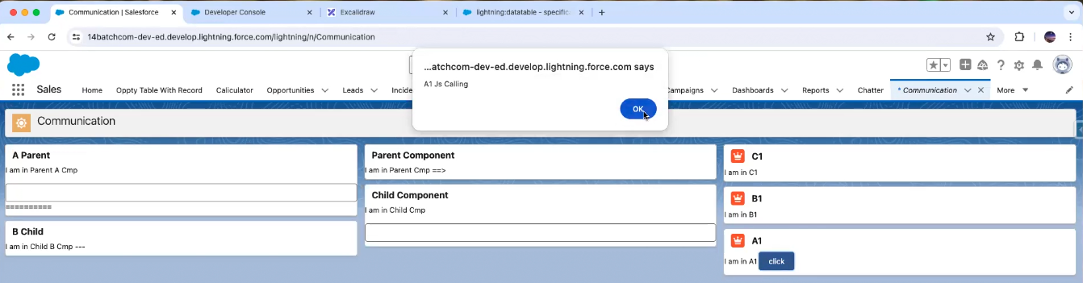

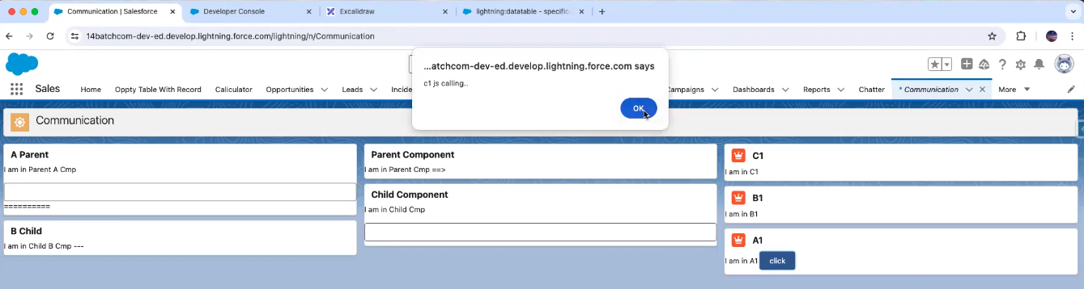

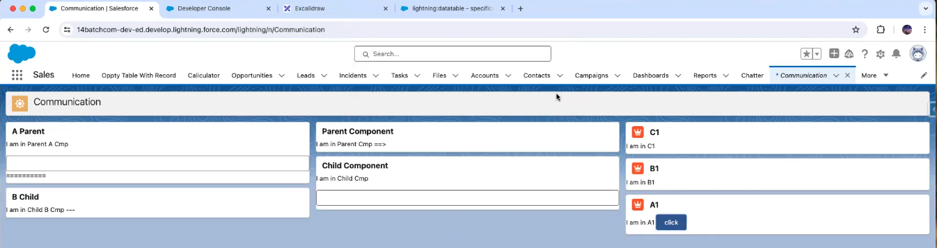

These are called event propagation

**Meaning of Propagation**

The word **propagation** means **movement, spreading, or passing along** something.

In the context of **events in Salesforce (or web in general)**:  
👉 **Event propagation = how an event moves through the component hierarchy** (from parent → child or child → parent).

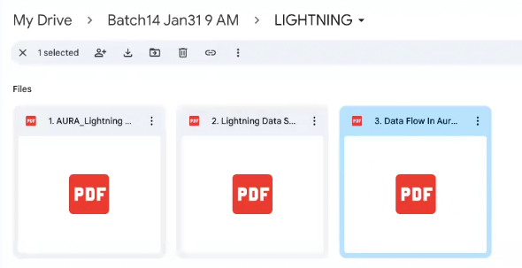

**Propagation = entire journey of event.**

**Traversing = direction of travel during that journey.**